Training of LEGS Trainers
for Pakistan- Summary of Evaluation Responses

Islamabad, Pakistan
11-16 January 2016

Introduction
The training evaluation has five components, which are described in order below. These are:
- Course objectives and relevance
- Workshop design
- Presentation
- Content
- Satisfaction

The LEGS ToT course has eight training objectives. These are as follows.
- Describe and apply the LEGS approach.
- Identify appropriate livelihood-based livestock interventions in emergency response.
- Design and implement response interventions according to LEGS standards and guidelines.
- State the principles of adult learning and apply them to delivering a training session.
- Describe the role and responsibilities of the trainer.
- Prepare and deliver a training session.
- Use a range of training skills and methods.
- Prepare and carry out a LEGS Training.

The first part of the evaluation form covers participants’ perceptions on the achievement of these objectives and the course’s relevance to their needs.

Course objectives and relevance
Objectives

For each course objective, the participants are asked to tick one of four boxes headed “Not met, Partly met, Mostly met, Fully met”.

A large majority of the participants indicated that each course objective was Mostly met or Fully met. These results from this part of evaluation are summarised in the table and charts below.

Table. Results from evaluation questions on course objectives

1.1 Do you think the following objectives of the training have been met? | Not met | Partly met | Mostly met | Fully met | No score
Describe and apply the LEGS approach | 0 | 3 | 10 | 14 | 1
Identify appropriate livelihood-based livestock interventions in emergency response | 0 | 0 | 15 | 12
Design and implement response interventions according to LEGS standards and guidelines | 0 | 0 | 13 | 13 | 1
State the principles of adult learning and apply them to delivering a training session | 0 | 4 | 14 | 8 | 1
Describe the role and responsibilities of the trainer | 0 | 0 | 12 | 15
Amend a training session | 0 | 1 | 12 | 14
Use a range of training skills and methods | 0 | 1 | 12 | 14
Plan and carry out a LEGS Training | 0 | 2 | 12 | 13

Charts. Participants’ responses on extent to which training objectives were met

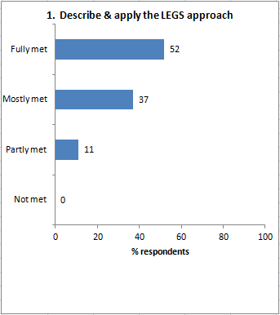 | 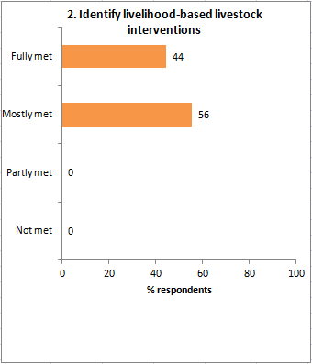
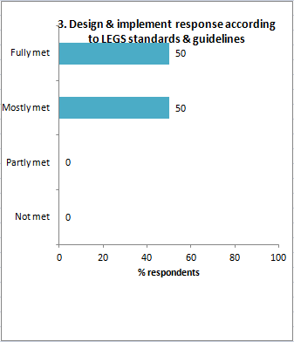 | 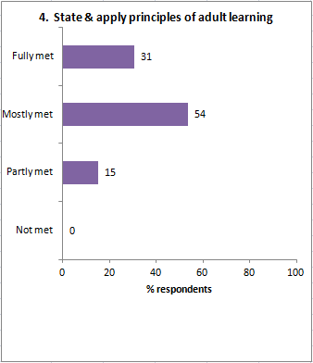
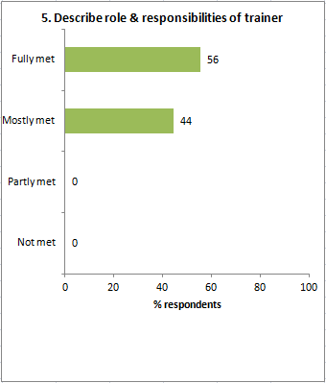 | 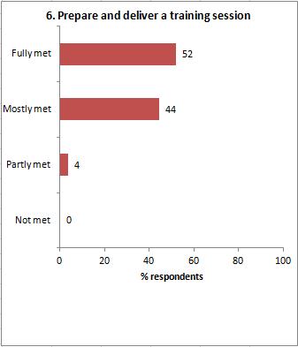
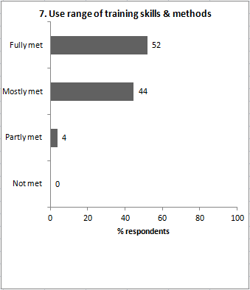 | 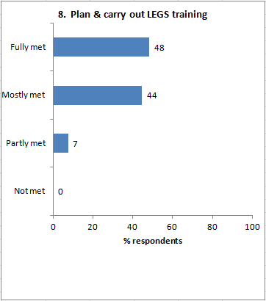

Relevance
The evaluation form asks, Was the course relevant for your work?

Twenty-five out of 27 participants responded. Twenty-four replied ‘Yes’ and one replied ‘No’.

They were asked ‘Why’, and the reasons given are:

- I am a member of emergency cell of my department.
- blank
- blank
- I am a veterinarian and can help farmers to support livestock, that is, the main livelihood of the people in emergencies.
- No direct relevance, but very useful for facing any disaster
- blank
- blank
- Because I am a veterinarian
- Because I am a veterinarian
- Because it deals with the livestock in emergency
- blank
- I work in Livestock Department, responsible for planning, development of livestock sector in country as a whole
- blank
- blank
- blank
- blank
- As I am a veterinarian, secondly working in Planning Section, so I can better incorporate the LEGS livelihood approaches in developing a project proposal
- blank
- I have been doing/arranging such trainings in the livestock field
- Because I am part of disaster response team and have to know what we do
- (1) Because I am professionally teacher and veterinarian, (2) I belong to Aworan District, which is passing through a complex situation of war, drought and earthquake.
- The course was very well or [sic] but since the most topics was not related
- Working with Disaster Management Authority, we have to coordinate preparedness and response plans. Learning from this ToT will be used to feed into plans for Livestock Department, which is a very important sector in Punjab.
- Because I am working in Livestock Department FATA
- Yes, Initial Assessment is relevant in my profession. We sometimes do Initial Assessment when Administration allows.
- As I am affiliated in the profession dealing with livestock
- blank

Workshop design
The evaluation form asks two questions, (i) What did you like about the overall design and structure of the course? and (ii) How do you think the design and structure of the ToT course can be improved?

What you liked
- Excellent
- blank
- blank
- This was designed and planned very well
- Good
- blank
- Good
- Simple, specific and SMART
- Very knowledgeable and confident trainers. Participatory techniques used in training.
- Seems tough at first, but was very innovative and participatory.
- It was very good
- The training was well designed and has structured or well defined contents. I liked the technique used for learning in this workshop.
- Overall design and structure of the course was specific and comprehensive
- blank
- The course was quite interactive and methodology of equal participation to ensure coordination while responding to emergency situations
- Logical ways
- Participatory approach, energiser and other techniques
- blank
- Book, handouts, group discussion, suggestion, getting comments
- Overall course guide us that how to protect the livestock
- The participatory work, presentations as well as presenters
- The design and structure of the course was well
- (1) The easy, friendly yet firm way in which facilitators carried out the session, (2) The facilitators' full grasp over the course content and their attention to each and every detail as well as all the participants.
- Good - the course was designed according to the livestock emergency plan and met all the steps necessary for disaster
- Good, excellent
- Good
- The course was very well structured, but since most topics were quite new for us, so we missed out to understand few important things in detail. [This participant missed two full days of the course due to important government commitments.]

How to improve
- Needs some more time.
- blank
- blank
- Making the session about one hour short [each session is currently 90 minutes].
- blank
- blank
- Yes, a little bit
- It's appropriate but somewhat lengthy
- blank
- Nice, but lengthy - could be shorter
- blank
- I believe it has a good design already and there is no need to improve it at the time being.
- blank
- blank
- blank
- blank
- Will be better to have another refresher course to remove the deficiencies
- blank
- By giving some realistic examples (by video, film, etc)
- No, it is good
- blank
- Yes it can be improved
- If participants are more encouraged to narrate examples from their own work experience
- More time may be needed to further improve the training
- Well if local trainer add with foreign trainers
- blank
- Yes it can be improved by translating the training course in more easy way so that participants can find it easy to understand

Presentation
The form asks, The presentation and facilitation of the workshop was: Poor, Adequate, Good, Very good.

The responses were:

Presentation evaluation: | Poor | 0 | Adequate | 0 | Good | 7 | Very good | 20

The form invites comments on each of the two trainers:

 | David Hadrill | Polly Bodgener
 | Great person, excellent facilitator. | Lovely presenter, very skilled trainer.
 | David | Polly
 | Key points well covered. Multiple learning styles. Humour and organization nicely done. | Excellent job. Nice connections to participants.
 | Impressive trainer. Good observer also. Communicated the material in very simple way. Really impressed by the training method of David. | Polly win the house. Communication and training style is outstanding.
 | Excellent | Very good
 | Very well prepared | Very well prepared
 | A very humble and kind person. Actively involved with all the participants. Having skill, competency and knowledge about training and the subject. | A very devoted lady. Actively engaged the participants in training.
 | Excellent | Excellent
 | Nice, knowledgeable, confident. | Knows well about subject. Understands people and interacts well with them.
 | Excellent | Excellent
 | David | Polly
 | Nice, confident. Speaks clearly and has command on its topic. | She is confident, friendly and has command on what she was doing.
 | Pleasant personality and excellent trainer. | Pleasant personality and excellent trainer.
 | Very nice and brilliant - Mr Mansoor
 | David Hadrill has full command on the technical interventions and his way of presentation is outstanding. | Polly has well engaged the participants in LEGS training activities. Presentation is well.
 | Mr David more attractive. Good speaking in clearness. Clear speaking. | She also good performer.
 | Ah! David was outstanding. Very much kind. Was very much easy to learn from him. | Was very friendly, organized and had full command on topics.
 | Quite knowledgeable, polite and good trainer. | Knowledge trainer.
 | Soft, focussed, smiley. Encouraging, having lot of technical background and really good trainer. | She is good trainer. Well prepared and method to teaching is excellent.
 | Very good and very active. | Very good and performed well.
 | I liked his attitude, the way he presents, encourage the trainees whether they are sometimes wrong. Well prepared. | Very good command on materials, participants. The attitude is very good and encouraging.
 | He is a well trainer. | She is also a well trainer.
 | Very knowledgeable. Friendly yet firm. Easy and clear word in spoken. Commitment and seriousness of purpose. Involving all. Clarity of concept. | Knowledgeable, clear concepts. Lively. Clarity in spoken and written form. Well organized.
 | Mr David was good trainer and act as good training. His approach was participatory and practical. | Was also a good trainer and perform well.
 | Very nice personality. Very good command on presentation. Clear voice. Understand trainer's language very well. | Very cooperative. Fast speaking. Difficult to understand her words in some time, but overall she is a good trainer.
 | Both trainers Polly and David's performance was good, but in my opinion David's way of teaching/training easily understandable to me. | She delivered very well.
 | Very good trainer and his cool way of presentation even helped us to understand things more easily. | She has a skill of reading minds of the participants that what they want to understand and what needs to be repeated again. Excellent job.

The form asks, Do you have any suggestions for alternative ways of facilitating the ToT training?

Comments were:
- No
- blank
- Perhaps more video examples
- No
- blank
- Training period will be from 9am to 3pm
- Refresher course needs to be arranged just after one month
- blank
- blank
- If some practical or field work is done
- No
- More female participation may help
- blank
- Time period should be increased
- blank
- Give response to gender
- To have in local language
- blank
- I think this is an excellent way. I have experience of being a trainer, but I learned a lot from this training course [respondent is University Professor]
- No
- To develop certain energising techniques relevant to the contents of the training, because people learn more from such kind of activities
- No
- blank
- Some visits may be kept for the part of ToT training (relief camp and disaster-affected area)
- No
- No
- n/a

Content
The form asks, ‘Which session or topic did you find most useful, and why?’

Comments were:
- Monitoring and evaluation
- First session: it covers almost the objectivity of ToT
- Monitoring
- PRIM, Initial Assessment, Monitoring
- PRIM practical one
- blank
- PRIM practical application
- PRIM and Response Plan and Adult Learning
- All sessions were equally useful because they provide practical information
- Adult learning - it was new and innovative approach
- Technical Interventions
- PRIM because it's a quick and reliable tool for planning intervention. Response Planning because it tells how to respond in emergencies.
- Preparing and Delivering Training
- PRIM
- PRIM, Technical Intervention, LEGS Handbook structure, Objectives, MS-KA-GN
- Tool of LEGS about Technical Intervention
- PRIM - it can make your plan better
- blank
- Livelihood and Livestock - perhaps it is more concerning with me and understood better
- All topic is useful
- All the topics were relevant and to the point
- Technical standards for veterinary support, because I am a veterinary doctor
- All very useful, very informative
- PRIM
- LEGS Initial Assessment and Monitoring/Evaluation
- Veterinary Service as I am affiliated with same type of duty
- All sessions, especially PRIM

The form also asks, ‘Which session or topic did you find least useful, and why?’

Comments were:
- [blank]
- n/a
- Introduction to LEGS Handbook
- Few Adult Learning Presentations
- blank
- blank
- blank
- No comment
- blank
- Closing - it was too long
- blank
- blank
- 'Response Intervention' as most being not relevant to local conditions
- blank
- blank
- Cross-cutting themes not being touched properly
- All were good, useful and inter-related
- blank
- Response Planning - really did not get it well, or I was unable to understand this session
- No
- blank
- Not one
- None
- No
- No comment
- blank
- blank

Last under Content, the form asks ‘Was there anything not included in the workshop that needs to be? If so, what is it?’

Comments were:
- [blank].
- n/a
- blank
- blank
- blank
- blank
- blank
- blank
- blank
- blank
- blank
- Not found anything
- Local conditions and interventions
- Yes, it needs to be
- MS 4, cash for livestock-based intervention
- blank
- blank
- blank
- blank
- blank
- blank
- No
- blank
- Cash for feed and fodder
- No
- blank
- n/a

Satisfaction
The form asks, ‘Overall, how would you rate this course?

The response was:

Satisfaction evaluation | Poor | 0 | Adequate | 0 | Good | 6 | Very good | 21

In response to ‘Any further comments’, comments were:

- blank.
- No
- blank
- blank
- A refresher course may be arranged of the LEGS ToT
- blank
- blank
- blank
- blank
- blank
- blank
- Nil
- Daily training duration to be reduced by at least one hour
- blank
- blank
- Involve gender in future training
- No
- blank
- blank
- blank
- blank
- Everything was well
- It was rather excellent
- Accommodation was not good as there were always disturbances, even at 1am
- No
- This type of training is very important and beneficial for all stakeholders. May arrange time to time as refresher.
- n/a

The form says, Tell us in one word how you would describe the training:
- Wonderful
- Excellent
- blank
- blank
- Excellent
- Very good
- Very good
- Excellent
- Excellent
- Amazing
- Excellent
- Excellent
- Excellent
- blank
- Excellent. Met all objectives of the training. Provided opportunity to professionals from diverse group of experience and background.
- Productive
- Productive
- Knowledgeable
- This training to combat disaster/emergency/drought
- Bank of knowledge/information
- Excellent and very much informative and productive
- Very well
- Magnicellent (magnificent and excellent)
- This training was good and useful
- (1) Leadership, (2) Learner
- Good
- Excellent

Comment by the respondent who answered ‘No’ to the relevance question.
The evaluation form states “What are your comments on [insert name of first trainer]:” and “What are your comments on [insert name of second trainer]:”. The Administrative Assistant is expected to type in the trainers’ names before printing the Evaluation Form, but failed to do so. Hence the confusion for a couple of trainees who wrote the trainers’s names rather than describing their performance.

