Training of LEGS Trainers Bangkok, Thailand

26 September to 01 October 2016

Introduction
All participants who attended the full six days evaluated the course using a standard LEGS ToT Evaluation Form. The forms were completed by the 16 ToT participants. The comments and statements below are typed verbatim, using the participants’ own words.

The training evaluation has five components, which are described in order below. These are:
- Course objectives and relevance
- Workshop design
- Presentation
- Content
- Satisfaction

The LEGS ToT course has eight training objectives. These are as follows.
- Describe and apply the LEGS approach.
- Identify appropriate livelihood-based livestock interventions in emergency response.
- Design and implement response interventions according to LEGS standards and guidelines.
- State the principles of adult learning and apply them to delivering a training session.
- Describe the role and responsibilities of the trainer.
- Prepare and deliver a training session.
- Use a range of training skills and methods.
- Prepare and carry out a LEGS Training.

The first part of the evaluation form covers participants’ perceptions on the achievement of these objectives and the course’s relevance to their needs.

It is optional to put one’s name on the evaluation form. All sixteen ToT participants completed the form. Most added their names.

Course objectives and relevance
Objectives

For each course objective, the participants are asked to tick one of four boxes headed “Not met, Partly met, Mostly met, Fully met”.

A large majority of the participants indicated that each course objective was Mostly met or Fully met. These results from this part of evaluation are summarised in the table and charts below.

Table. Results from evaluation questions on course objectives

1.1 Do you think the following objectives of the training have been met? | Not met | Partly met | Mostly met | Fully met | No score
Describe and apply the LEGS approach | 0 | 0 | 5 | 11 | -
Identify appropriate livelihood-based livestock interventions in emergency response | 0 | 0 | 5 | 11 | -
Design and implement response interventions according to LEGS standards and guidelines | 0 | 0 | 4 | 12 | -
State the principles of adult learning and apply them to delivering a training session | 0 | 0 | 3 | 13 | -
Describe the role and responsibilities of the trainer | 0 | 0 | 6 | 10 | -
Amend a training session | 0 | 0 | 6 | 10 | -
Use a range of training skills and methods | 0 | 0 | 4 | 12 | -
Plan and carry out a LEGS Training | 0 | 0 | 6 | 10 | -

Charts. Participants’ responses on extent to which training objectives were met

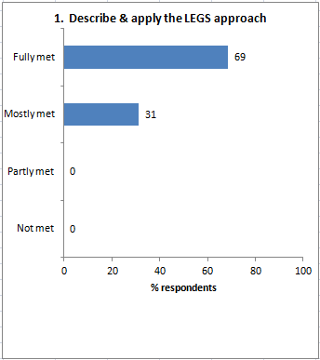 | 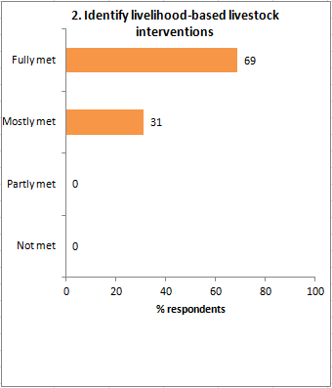
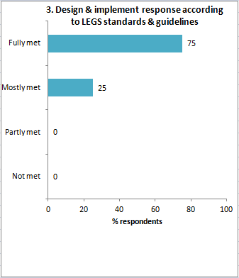 | 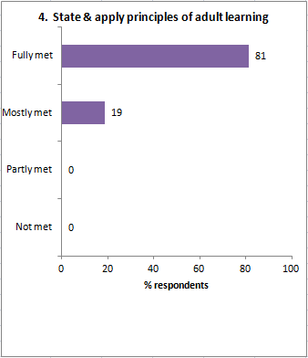
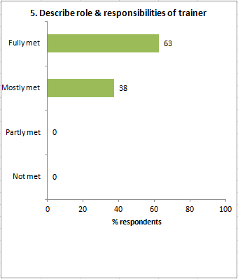 | 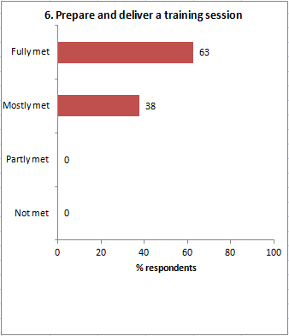
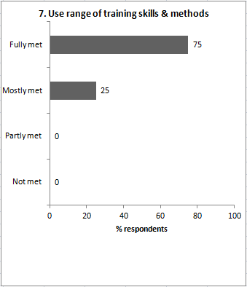 | 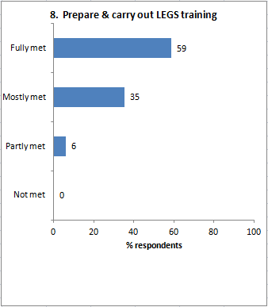

Relevance
The evaluation form asks, Was the course relevant for your work? Responses were:

Relevance
Yes | No | “Somehow” | No response | Total
11 | 2 | 1 | 2 | 16

They were asked ‘Why’, and the reasons given are:

Yes
- (no name) I work as freelance and have experience on humanitarian work. LEGS training has been useful to acquire new set of skills which I am going to use in my future work (trainings, assessments, evaluations, etc.).
- (Jiige) I’m dealing with emergency projects and going to organize the LEGS in 10 days.
- (Sushmita) In my current profile I work in disaster-prone area so it helps me work with stakeholders to prepare better for communities who are dependent on livestock.
- (Mathias) It did definitely intensify my knowledge about LEGS; the tools to be a trainer were given and have been thoroughly passed on by the two trainers.
- (no name) [no comment]
- (Ephraim) Catholic Relief Services (CRS) implements projects on CAHWs, agro-vets and provision of livestock/ restocking.
- (Mandefro) I am humanitarian worker and responsible to ensure quality and accountability to any work/responses. Thus, it helps.
- (James) Because planning for drought disasters do occur and LEGS concepts are needed.
- (no name) [no comment]
- (Nidal) Veterinary work in Ministry/animal field.
- (Ali) [no comment]
Somehow
- (Saeideh) We work for empowering vulnerable groups, so it definitely helps us and is essential to train others. On the other hand, we didn’t work directly about livestock so far.
No
- (Mario) I work for Government, but have little/no responsibility to conduct LEGS training.
- (Rakesh) Because I’m working in livelihood-based breed improvement of goat and vegetable production programme.
No response
- (Govinda)
- (Andro)

Workshop design
The evaluation form asks two questions, (i) What did you like about the overall design and structure of the course? and (ii) How do you think the design and structure of the ToT course can be improved?

What you liked
- (no name) The training was highly participatory. Gender balanced trainers (male and female). It helped learning first and then practicing it.
- (Jiige) Structure and clear instruction (command).
- (Sushmita) It has complementary trainers. There was time for practice sessions. The environment was very supportive and positive not at all critical negatively, particularly feedback sessions.[after training practice]
- (Mathias) Will split in 1st the LEGS approach, then 2nd training elements. At the same time, the trainers exercises again intensify the LEGS knowledge. The two handouts sent by email to read beforehand plus the questions are very useful. It is good to say to bring the answers, even if they are not considered during the course. It helps to prepare.
- (no name) Structure, interventions.
- (Ephraim) A lot about designing around technical interventions.
- (Mandefro) I like most the content and process of the workshop.
- (James) It was participatory. Had full content and various training methods. Dedicated trainers with training passion.
- (no name) Useful for both livestock-related and humanitarian field.
- (Nidal) [no comment]
- (Ali) [no comment]
- (Saeideh) Very nice, but it probably can be held in other countries that have more participants [there were no Thai participants even though training was in Bangkok].
- (Mario) Overall structure and design of this course is good to be understanding for all participants.
- (Rakesh) [no comment]
- (Govinda) Good.
- (Andro) [no comment]

How to improve
- (no name) The adult learning principles and the use of different [training] tools can be divided in all six days to facilitate more demonstration (please see back of this page). [on back of page, the first part of the agenda each day is highlighted with topics like Adult Learning, Using Flipchart, Using PPT, Using Case Study, …)
- (Jiige) Right now don’t have any suggestion but I’ll provide feedback after completing my first training.
- (Sushmita) Giving some homework at the end of every day (small homework).
- (Mathias) [no comment]
- (no name) [no comment]
- (Ephraim) I think that it’s fine, but the LEGS handbook needs improvement, for instance, there are no standards for mass vaccinations.
- (Mandefro) As per my understanding, it is nice. But, for improvement, new learnings should be included from different parts of the world, thus, it requires to work closely with colleagues abroad.
- (James) Increase training by one day, because the last day the participant loses concentration because of thinking of travelling.
- (no name) Include more real case studies.
- (Nidal) [no comment]
- (Ali) [no comment]
- (Saeideh) [no comment]
- (Mario) [no comment]
- (Rakesh) No, it is satisfactory.
- (Govinda) It can be abundant from time to time according to change happened for world.
- (Andro) [no comment]

Presentation
The form asks, The presentation and facilitation of the workshop was: Poor, Adequate, Good, Very good.

The responses were:

Presentation evaluation: | Poor | 0 | Adequate | 0 | Good | 4 | Very good | 12

The form invites comments on each of the two trainers:

 | Ana Urgoiti | David Hadrill
 | (no name) Highly energetic Uses flipchart exceptionally well. Use of other tools/methods also good. | Wonderful trainer. Links learning to various experiences. Sometimes low in voice. Visiting to participants groups can be improved which will help participants get more connected.
 | (Jiige) Thank you. | Thank you.
 | (Sushmita) Very energetic, very good facilitator once hurt my feelings for animals – maybe a little more sensitive about animals. | Very calm, very composed, complementing Ana nicely. Perhaps could initiate some group works. It will help know how calmly you can manage that.
 | (Mathias) Excellent animator. Thorough knowledge about training methodologies, but as well livelihoods and humanitarian approach. Very positive person! | Similarly excellent presenter, very thorough knowledge. Spreads confidence and a certain comfort among participants! Extremely professional and friendly.
 | (no name) Very good, thanks. | Very good, thanks.
 | (Ephraim) Good presenter and trainer. | Good presenter and trainer.
 | (Mandefro) Keep up the style you used along the course of the training. Pleased meeting you! | I like the way you handled the sessions and your technical explanations which based on your life-long experiences. Pleased meeting you!
 | (James) Well experienced knowledgeable trainer. | Good trainer. Humble.
 | (no name) She created such a casual environment which really helps someone as shy as me. | Helpful, supportive and always ready and willing to help.
 | (Nidal) No comments, she is very good. | He is very good.
 | (Ali) She is nice to be as trainer | He is good LEGS trainer.
 | (Saeideh) [no comment] | Sometimes he talks a bit fast (of course, because he’s native).
 | (Mario) Good trainer. | Excellent trainer.
 | (Rakesh) Very impressive presentations which we learnt more. | Very much impressive and sound knowledge of presentations so we could also presentation further in trainings.
 | (Govinda) No comments. Brilliant in every training session. | No comments: excellent with brilliant personality.
 | (Andro) I like the energy, it’s make me keep awake! Ana was explained the LEGS in simple way which for important to keep it out the new things. | I acknowledge David has a lot of experience and expertise. He also respectful with all the participants which really good example for the trainers.

The form asks, Do you have any suggestions for alternative ways of facilitating the ToT training?

Comments were:
- (no name) Try design may have use of tools/methods (tips for each) on every day morning for 15 to 20 minutes, to demonstrate and learn, and then continue the training.
- (Jiige) [no comment]
- (Sushmita) No.
- (Mathias) No.
- (no name) [no comment]
- (Ephraim) I think the training assumed logic model for knowledge. There is need to facilitate logic modelling such as results framework.
- (Mandefro) [no comment]
- (James) Introduce or employ pod-casting, a pre-recorded audio LEGS messages as a training method.
- (no name) No.
- (Nidal) No.
- (Ali) No.
- (Saeideh) [no comment]
- (Mario) No suggestions.
- (Rakesh) No.
- (Govinda) Not none. If I will facilitate or conduct then I will give my inputs.
- (Andro) Keeping more simple the material/subject, thus, it’s made more easy to understand.

Content
The form asks, ‘Which session or topic did you find most useful, and why?’

Comments were:
- (no name) PRIM was completely new loved understanding it. Response identification new because of decision-making tree, advantages/disadvantages table, etc.
- (Jiige) The session 2 that puts basis for next sessions.
- (Sushmita) How to use LEGS handbook to understand it in sequence making meaning out of it.
- (Mathias) Intro to handbook; gives the necessary “feeling” for the book.
- (no name) [no comment]
- (Ephraim) Analysis of technical interventions because it is more relevant to my work.
- (Mandefro) All were relevant and engaging.
- (James) PRIM.
- (no name) Technical interventions because we go and apply that right now.
- (Nidal) Livestock and livelihoods and emergencies.
- (Ali) ToT session.
- (Saeideh) Cross-cutting themes / core standards.
- (Mario) 4 stages of LEGS.
- (Rakesh) The topic PRIM is most useful for me that is now useful for livestock emergency.
- (Govinda) Core standard. To measuring the standard for whole world.
- (Andro) Principle of LEGS, Participation, Four stages of LEGS, Adult Learning method. Tips and tricks during ToT from both trainers.

The form also asks, ‘Which session or topic did you find least useful, and why?’

Comments were:
- (no name) n/a.
- (Jiige) -.
- (Sushmita) Perhaps the last day session 1/2: I do not remember exactly what the topic, perhaps qualities of trainer.
- (Mathias) -.
- (no name) [no comment]
- (Ephraim) Introduction to the LEGS handbook – it was not well focussed. I think it was not appropriate to start the session with a discussion on quality and accountability.
- (Mandefro) None.
- (James) None.
- (no name) [no comment]
- (Nidal) Couldn’t find one.
- (Ali) -.
- (Saeideh) [no comment]
- (Mario) Introduction to know the structure of LEGS handbook.
- (Rakesh) -.
- (Govinda) Not
- (Andro) Planning to be LEGS trainer. It’s not meant it’s not useful but compared with the other topics I think this is the least useful.

Last under Content, the form asks ‘Was there anything not included in the workshop that needs to be? If so, what is it?’

Comments were:
- (no name) n/a.
- (Jiige) -.
- (Sushmita) No.
- (Mathias) Nothing thought of right now.
- (no name) [no comment]
- (Ephraim) Yes, there is a need to introduce some facilitation on logic models to help design of response plan on technical interventions.
- (Mandefro) -.
- (James) No.
- (no name) Case studies on landslides and earthquakes.
- (Nidal) No.
- (Ali) -.
- (Saeideh) [no comment]
- (Mario) Aspect on animal welfare is not to be present at the learning process.
- (Rakesh) No.
- (Govinda) No.
- (Andro) [no comment]

Satisfaction
The form asks, ‘Overall, how would you rate this course?

The response was:

Satisfaction evaluation | Poor | 0 | Adequate | 1 | Good | 2 | Very good | 13

The respondent who scored it adequate submitted form number 13.

In response to ‘Any further comments’, comments were:

- (no name) n/a.
- (Jiige) [no comment]
- (Sushmita) There can be a banner for the training.
- (Mathias) To my opinion, within the cross-cutting issues, PLHIV should be reformulated; it should go into the direction of “high vulnerability” in order not stigmatize.
- (no name) [no comment]
- (Ephraim) None.
- (Mandefro) To increase the demand and use of LEGS, LEGS Coordinator need to work on the promotion and adoption to any livestock related response.
- (James) I would suggest pod casting method of training be included in the training package.
- (no name) No
- (Nidal) [no comment]
- (Ali) Overall it was a good organized training.
- (Saeideh) [no comment]
- (Mario) -.
- (Rakesh) -.
- (Govinda) No
- (Andro) I am not sure how could manage it, but I think to attend 6 days training is really exhausted for the participants.

The form says, Tell us in one word how you would describe the training:
- (no name) Excellent
- (Jiige) Useful
- (Sushmita) Awesome!!!
- (Mathias) Excellent, friendly motivating week will stay in the memory and lots was learned!
- (no name) Happy
- (Ephraim) Practical
- (Mandefro) Spectacular!
- (James) Comprehensive
- (no name) Excellent
- (Nidal) Very good
- (Ali) Good
- (Saeideh) A great experience and coordination
- (Mario) Amazing
- (Rakesh) It is very useful for me and want to apply it in my field and country
- (Govinda) Excellent
- (Andro) Really good and very organized!

