LEGS Burkina Faso TOT 12-17 April 2015: Participants’ Evaluation
Introduction
The participants evaluated the course using the standard LEGS ToT Evaluation Form.

Course objectives and relevance
Objectives
The LEGS ToT course has eight objectives:
- Describe and apply the LEGS approach.
- Identify appropriate livelihood-based livestock interventions in emergency response.
- Design and implement response interventions according to LEGS standards and guidelines.
- State the principles of adult learning and apply them to delivering a training session.
- Describe the role and responsibilities of the trainer.
- Amend a training session.
- Use a range of training skills and methods.
- Plan and carry out a LEGS Training.

For each course objective, the participants are asked to tick one of four boxes headed “Not met, Partly met, Mostly met, Fully met”.

Every participant indicated that each course objective was Mostly met or Fully met. The single exception was one participant who recorded that the course objective “Design and implement response interventions according to LEGS standards and guidelines” was partly met.

These results are summarised in the table and charts below.

Table. Results from evaluation questions on course objectives

1.1 Do you think the following objectives of the training have been met? | Not met | Partly met | Mostly met | Fully met
Describe and apply the LEGS approach | 0 | 0 | 4 | 14
Identify appropriate livelihood-based livestock interventions in emergency response | 0 | 0 | 3 | 15
Design and implement response interventions according to LEGS standards and guidelines | 0 | 1 | 5 | 12
State the principles of adult learning and apply them to delivering a training session | 0 | 0 | 6 | 12
Describe the role and responsibilities of the trainer | 0 | 0 | 5 | 13
Amend a training session | 0 | 0 | 7 | 11
Use a range of training skills and methods | 0 | 0 | 9 | 8
Plan and carry out a LEGS Training | 0 | 0 | 6 | 12

Charts. Participants’ responses on extent to which training objectives were met

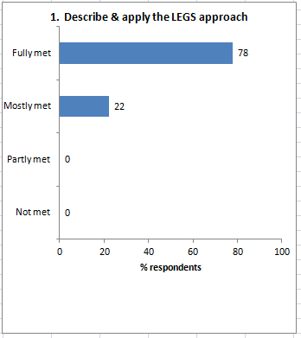 | 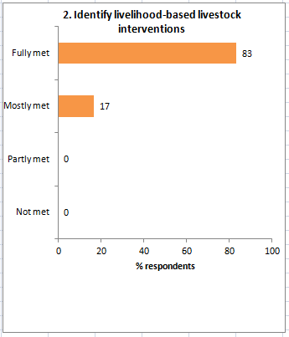
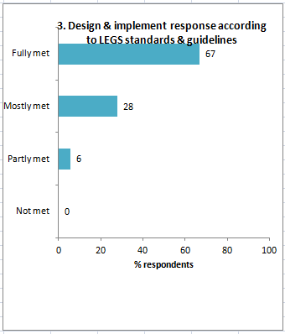 | 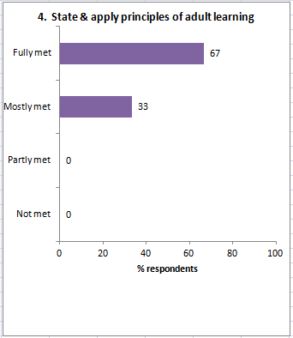
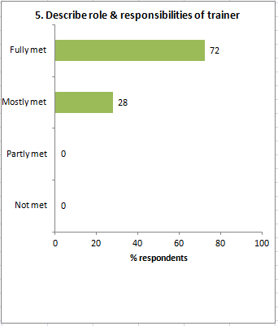 | 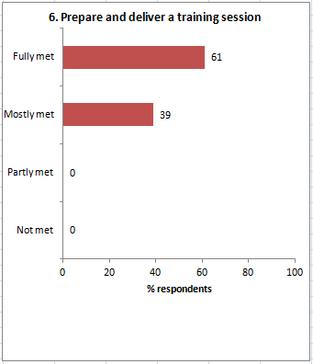
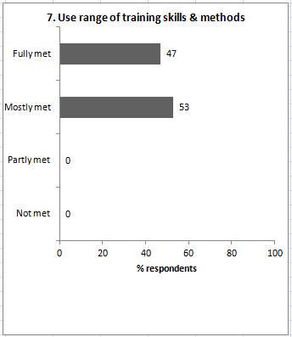 | 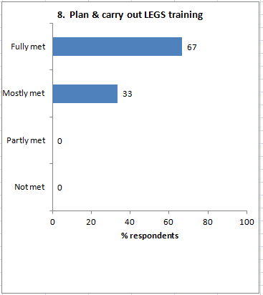

Relevance
The evaluation form asks, Was the course relevant for your work?

All 18 participants (100%) responded replied ‘Yes’.

They were asked ‘Why’, and the reasons given are:
- It supports disaster management in slow and rapid-onset emergencies
- We work in an environment of slow onset emergencies, so this will be very useful for preparedness.
- It will allow us to better design an emergency project related to livestock.
- The training tackles situations that I face in my work.
- It is relevant because we are planners and this allows an inclusive and comprehensive vision.
- All my expectations were fulfilled.
- It is relevant. I work in a region of Niger that is threatened by drought.
- I have never worked in an emergency situation so in case of planning for a disaster this will help me.
- In my work we have to manage several stakeholders together.
- It is an innovation that will allow me to be efficient when an emergency situation breaks out.
- It allows me to approach more easily emergency issues in my activities.
- Relevant because I was implementing technical interventions like restocking without analysing the context, but with the training I fully understand the process.
- The training was very beneficial to me.
- Relevant because I’m a trainer and I intervene in emergency situations.
- It gave me competencies that will improve my interventions.
- It will allow me to take livestock into account as a means of livelihood in designing response.
- As a livestock specialist this will help me much better support partners and beneficiaries.
- Enables greater efficiency in livestock emergencies.

Workshop design
The evaluation form asks two questions, (i) What did you like about the overall design and structure of the course? and (ii) How do you think the design and structure of the TOT training course can be improved?

What you liked
- -
- Documentation, participation and practical exercises.
- Formidable.
- Good time-keeping. The sessions are well designed.
- Anticipation in planning. Methodology. The cultural diversity of participants.
- The specific way to deliver the training. The style of the trainers and rigorous time-keeping.
- It is all very well structured for methodology and pedagogical tools.
- A clear and short outline with all tools to deliver the training. Impeccable logistics. Friendly atmosphere.
- Keeping to time, Trainers are courteous. Well structured.
- The training was SMART, which explains its full success.
- Design, training material and quality of the trainers.
- The organisation of the training and the way it was delivered by the trainers.
- The way I was trained was perfect thanks to the the efficiency and dynamic of the trainers.
- The sequence of steps.
- The group dynamic. The trainers’ methodology.
- Training was well organised and very practical.
- The spirit of the group and the trainers for their know-how. It was great.
- Convivial, the pedagogical style.

How to improve
- -
- More preparation time for the trainer practice sessions.
- There should be more state officers represented among the participants; more of the sub-regional countries should have been present.
- No comment.
- Include potential donors at the end of the training to explore potential funding possibilities.
- –
- No comment.
- –
- No comment.
- No.
- Have a free afternoon after two days of non-stop.
- No comment.
- –
- Make co-facilitation compulsory.
- N/a.
- [second page blank]
- Ensure all participants have costs covered by LEGS.
- More interaction and case studies.

Presentation
The form asks, The presentation and facilitation of the workshop was: Poor, Adequate, Good, Very good.

The responses were:

Presentation evaluation: | Poor | 0 | Adequate | 0 | Good | 4 | Very good | 13

Note: one no response: one respondent (form no. 16) appeared not to notice that the evaluation form had a second page.

The form invites comments on each of the two trainers:

 | David | Claire
 | Very courteous, humble and works hard. Gets by in French. | Great open-mindedness, very cultivated, courteous, works hard
 | Excellent knowledge of the subject. French is difficult but message gets through. | Knows the topic and particularly training methodology.
 | Very good with few language difficulties. | Excellent, especially on responding to questions.
 | Excellent knowledge of the subject. Easily understandable. | Excellent facilitating and expresses herself clearly.
 | Very good trainer, excellent and friendly. | Very good trainer, excellent and friendly.
 | Very brilliant trainer. Good knowledge of LEGS. | Very brilliant translator and good knowledge of LEGS.
 | Great experience, with very relevant interventions. | Great pedagogical skills and knows how to use the right words to clarify a concept or idea.
 | Not very at ease in French, but manages to make himself understood and calls on Claire when he needs to. | Clear expression. Manages to make herself understood easily.
 | Good knowledge of the subject. Experienced. | Perfect!! Good synergy with David at all levels.
 | Excellent facilitator, courteous, smiling, calm and efficient. | Claire Boulanger was simply super, very disciplined, friendly and very methodical. Bravo and bon courage.
 | Pondéré: level-headed, experienced and very attentive. | Attentive, very experienced, professional and rigorous.
 | Good trainer. | Good trainer.
 | Both dynamic and very close to the trainers. Hats off to them! | Both dynamic and very close to the trainers. Hats off to them!
 | Very positive. | Very positive.
 | They are the best. | They are the best.
 | - | -
 | David is an expert. He must just improve in French. In any case, he knows what he is talking about. | Claire has helped a lot in understanding concepts.
 | Calm, attentive, pedagogue. | Attentive, pedagogue, calm and smiley.

The form asks, Do you have any suggestions for alternative ways of facilitating the TOT training?

Comments were:
- Use PowerPoint with as much flipchart as possible.
- –
- No.
- No comment.
- –
- –
- No.
- –
- No comment.
- –
- –
- No comment.
- No.
- No.
- n/a
- –
- It would be nice to have the training over four days.
- More interactions and more case studies, c.f. 2.2.

Content
The form asks, ‘Which session or topic did you find most useful, and why?’

Comments were:
- Programming emergency intervention because that helps recapitulation of other chapters.
- Use of PRIM: very participatory and helps realistic decision-making.
- Preliminary assessment.
- M & E. It’s not very often taken into account in project design and often causes trouble in implementation.
- All sessions useful.
- PRIM because is enables choosing the best and most appropriate technical intervention.
- Presentation of LEGS and familiarisation with the manual.
- All sessions were most useful because they are inter-dependent.
- Learning how to use of the manual, and its layout because it’s the base of the training.
- All sessions were useful because they were complementary.
- Response identification, because it concerns situations I have faced.
- All sessions were useful for me because they allow implementing identified interventions by a logical process.
- Session 1.
- The session on Preliminary Evaluation. It is the basis for everything.
- Technical interventions and choice of options.
- –
- All sessions were useful to me. The six session were all useful and well explained.
- Session 5, it is about the operational phase of a LEGS intervention.

The form also asks, ‘Which session or topic did you find least useful, and why?’

Comments were:
- Everything was useful
- –
- No.
- No comment.
- None.
- –
- Sessions are all part of a bigger picture and all useful.
- –
- Nothing.
- –
- –
- No comment.
- –
- –
- Rapid-onset emergency because we are in West Africa.
- n/a
- No comment.
- –

Last under Content, the form asks ‘Was there anything not included in the workshop that needs to be? If so, what is it?’

Comments were:
- More depth on cross-cutting issues.
- –
- –
- No comment.
- –
- –
- No.
- –
- No.
- No.
- Yes, how to contribute to the evolution of the LEGS Project [Olivier]
- No.
- No.
- No.
- No.
- –
- No comment.
- –

Satisfaction
The form asks, ‘Overall, how would you rate this course?

The response was:

Satisfaction evaluation | Poor | 0 | Adequate | 0 | Good | 2 | Very good | 15

In response to ‘Any further comments’, comments were:

- Compatible, dynamic and mutually supportive group.
- I liked the group dynamic and the participants’ sense of responsibility. Bravo!
- When planning the training, it would have been better if participants came in pairs from a country so that there would be two who could help one another to carry out the training in their countries.
- No comment.
- –
- –
- –
- –
- Share a real life situation in which LEGS was applied.
- –
- –
- No comment.
- –
- Trainers were very professional.
- No comment.
- –
- No comment.
- –

In one word:
- Learning methods and means of technical interventions in emergencies.
- Super
- –
- Super !!! This training is like a glass of water for a traveller in the middle of the desert.
- I would describe this training as an opportunity to discover gaps in our role as a development officer and overcome them. Formidable.
- Good training methodology.
- A success.
- It allowed me to plan an emergency response for livestock.
- Excellent.
- SMART superbement.
- Very good.
- Excellent.
- The objective was achieved.
- Success.
- A very participatory training.
- –
- This training is a great asset for my career.
- Excellent.

