Livestock Emergency Guidelines & Standards

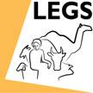

Middle East Region

Training of LEGS Trainers

Istanbul
08 to 13 December 2013

Summary of Evaluation

Course objectives and relevance
Objectives
Results are summarised in the table and charts below.

Table. Results from evaluation questions on course objectives

1.1 Do you think the following objectives of the training have been met? | Not met | Partly met | Mostly met | Fully met
Describe and apply the LEGS approach | 0 | 0 | 3 | 17
Identify appropriate livelihood-based livestock interventions in emergency response | 0 | 0 | 1 | 19
Design and implement response interventions according to LEGS standards and guidelines | 0 | 0 | 5 | 15
State the principles of adult learning and apply them to delivering a training session | 0 | 0 | 9 | 11
Describe the role and responsibilities of the trainer | 0 | 0 | 6 | 14
Prepare and deliver a training session | 0 | 2 | 6 | 12
Use a range of training skills and methods | 0 | 0 | 8 | 12
Plan and carry out a LEGS Training [one no response] | 0 | 1 | 9 | 9

Charts. Participants’ responses on extent to which training objectives were met

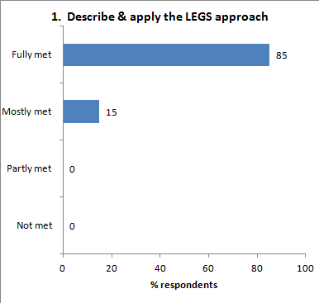 | 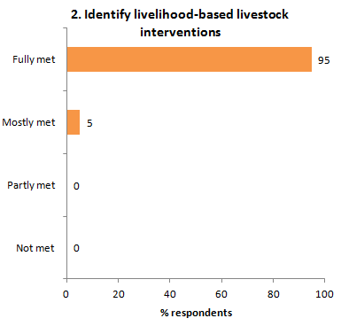
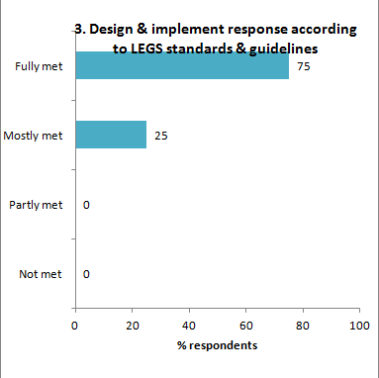 | 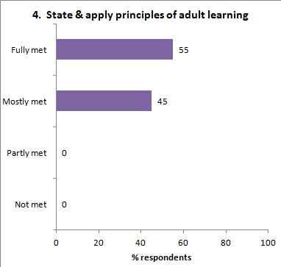
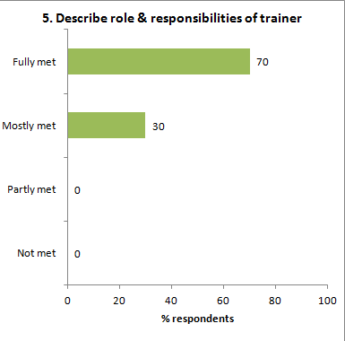 | 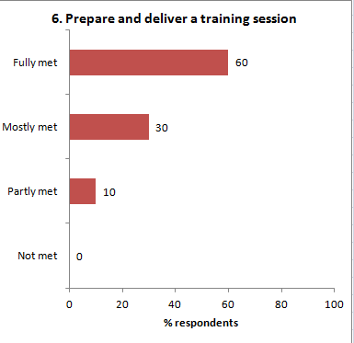
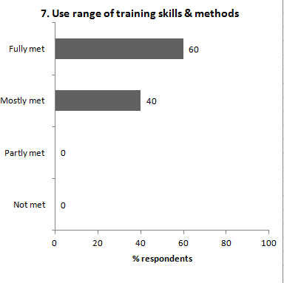 | 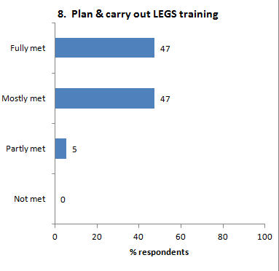

Relevance
The evaluation form asks, Was the course relevant for your work?
Twenty respondents (100%) replied ‘Yes’.

They were asked ‘Why’, and the reasons given were:

- (i) I will be able to advocate for the use of LEGS. (ii) I will be able to use it and include LEGS during the needs assessment and response. (iii) I will train other ACF staff and INGO.
- I am involved with organisations who need expertise in emergency situations.
- Now I can better navigate into LEGS handbook and deliver the right process and information from it.
- It helped me how to deal with emergency and disaster which threatened my country.
- Yes, which we are implementing emergency projects.
- My work is response to the emergency.
- We are any subject to face emergency case as livestock concern people.
- It helps me to improve, or trying to improve, the emergency response in my country.
- Because my country is disaster-prone country and most of the people are smallholder livestock keepers. As a development worker I could help them to cope the DRR.
- Because the population where I work are subject to shocks and disasters and I also work with livestock, both of these factors make the LEGS approach relevant for me.
- My qualification is on livestock production management so this course is very close to my job.
- I work in emergency settings responsible for livestock programme.
- I am teaching and training at different levels so it was extremely useful and relevant to my work, especially in voluntary activities.
- My daily work with farmers and the interventions we implement need a tool for organising so LEGS will be the solution.
- I work with livestock farmers and my advice is always sought.
- Yes, as working for an NGO in Gaza Strip which is likelihood exposed to crisis and the situation of livestock in Gaza needs to be improved.
- Yes. I work with pastoral communities whose livelihoods rely entirely on livestock and are prone to disaster.
- Yes. Will need it for advocacy.
- Yes. I am involved in emergency intervention related to livestock since 13 years and I think LEGS is suitable guideline to be considered.
- Yes.

Workshop design
The evaluation form asks two questions, (i) What did you like about the overall design and structure of the course? and (ii) How do you think the design and structure of the TOT training course can be improved?

What you like
- The mix of activities and mix of participants.
- Group work.
- The sessions presented by participants. Reminder.
- Very attractive.
- –
- It was well organised, well structured.
- Clearly.
- It’s very informative and effective.
- Yes.
- I like the structure approach and the continued focus on reaching the objectives.
- Participatory approach.
- The content of the course. The book. The facilitation.
- Very well designed.
- Managing the time. Facilitating.
- –
- Interactive between the trainers and participants, and between participants. The content clear and easy to apply.
- Adequate time allocation for each session on LEGS.
- Well planned and delivered.
- Well organized.
- –

How to improve
- There should be more real cases i.e. practical situations.
- no comment.
- Give only 60 minutes for participants’ sessions [training practice]. Insist on delivery rather than repeating details.
- no comment
- =
- –
- To give more time.
- By concentrating the training into an area of country that has a lot of disasters and crisis.
- It’s OK. In future it should address based on disaster.
- Somehow to leave more time for the trainers to prepare their presentations.
- Practical material/ maybe training video programmes from emergency regions.
- None.
- –
- By having more training and experience.
- Too structured. No flexibility. Its structure should be flexible.
- More working groups and training [can’t read word].
- More time could be allocated to training preparation and practice.
- Maybe give it more time (one more day).
- Enrich it with specific case studies related to the trainees’ context.
- To improved by more case study and practice work.

Presentation
The form asks, The presentation and facilitation of the workshop was: Poor, Adequate, Good, Very good.

The replies were:

Presentation evaluation: | Poor | 0 | Adequate | 1 | Good | 4 | Very good | 15

The form invites comments on each of the two trainers:

 | David | Polly
 | Very diplomatic. I won’t mind if you were more direct. | Lot of energy. Very strong experience as a trainer.
 | Calm, polite and dedicated to his task. Interactive. | Interactive, polite and dedicated to her task.
 | Very good and inspiring for conducting LEGS session. | Very good.
 | Cooperative. Good facilitator and helpful. | Cooperative. Good facilitator and friendly.
 | He is an excellent and professional trainer. | She is the same, but for me she is doing faster. I think this was my problem, not she.
 | Excellent | Excellent.
 | Excellent | Excellent
 | Very good and intelligent. He has the skills to be a very good trainer. | Very good, cooperated and coordinated.
 | Very good. | Very good.
 | Has an open style as a trainer. Leaves time for feedback. Sensitive to quieter people in the group. Very non-threatening. | Made participants have confidence in her. Obviously has done a lot of training and seems very experienced and seemed to know and understand the subject very well.
 | David was great. Patient, respectful, friendly. I did not watch any negative issues to him. | Polly did well. Patient, wonderful and honest.
 | He is mastering the subject. Patient. Has full control without authority. Confident, friendly. | She is friendly, encouraging, she has extensive knowledge about the subject. Know the tricks of delivering the training.
 | Very considerate, although firm but not harsh. | Outstanding trainer. Draws sharp lines at appropriate points.
 | Lovely man. | She needs to smile more.
 | Good. He knows his stuff. Polite. | Excellent. She knows her stuff. A little bit pushy at times.
 | Excellent trainer, calm. Don’t spread tension to the participant so he make the sessions so relaxed and comfortable. | Active, positive.
 | Excellent and interesting. | Excellent.
 | Perfect. | Perfect.
 | Good blend
 | Has solid background in livestock which enriches the presentation. | Good facilitator.
 | David is excellent trainer. He has the realistic experience in this field. David is good listener and he looks after so many [can’t read word]. | Polly is very strong in participation issue. She is very great trainer and knows from where she start if the goal she looks for.

The form asks, Do you have any suggestions for alternative ways of facilitating the TOT training?

- No comment
- No comment
- Work group, case studies should not be made by more than four to five people.
- I admire this way.
- -
- No and I will copy it and do the same.
- -
- -
- n/a
- -
- Preparation of documentary film from emergency districts and LEGS achievement.
- No.
- No.
- No.
- One trainer plus two co-trainers for variety.
- No.
- Allocating more time to practice sessions.
- No.
- Think more about case study.
- Yes. [no further comment]

Content
The form asks, ‘Which session or topic did you find most useful, and why?’ Comments were:
- PRIM.
- All sessions were useful, especially PRIM due to response analysis.
- PRIM and M & E.
- PRIM. Hleped me to select appropriate intervention.
- All was most useful. We had emergency experience but now I know how I can use LEGS in the targeted community.
- Useful, all. But the presentation that we did was the best.
- Response on slow-onset. Usually we are facing this kind of situation.
- The final one because it will measure the work you will do.
- All sessions are very much useful and effective. It is inter-related to each other.
- Practicing the training myself, but also observing and learning from other participants doing the presentation.
- PRIM because I was in the group and presented a lecture.
- All.
- Adult learning as I intend to spend more time in this activity.
- All of them.
- M & E.
- M & E, I need to improve myself in this part so I felt that I have additions from this course.
- PRIM.
- Last session. It’s always ignored.
- M & E because it is my interest.
- All is the same level. PRIM is very important.

The form also asks, ‘Which session or topic did you find least useful, and why?’ Comments were:
- M & E because I have found it is usually the topic everybody covers so it was a bit of repetition.
- [no comment]
- no comment
- –
- I have not anything. For me, all was useful.
- –
- –
- The first one.
- n/a
- The session on potential LEGS trainings that we as trainers may carry out perhaps went on too long.
- Really not applicable.
- None.
- None.
- No.
- None.
- n/a
- M & E because I have not been so much involved in it.
- None. They were equally important.
- Livelihood framework. Way of the presentation was not so clear.
- Vet Services. It need more of details that’s how can be more implementation in it.

Last under Content, the form asks ‘Was there anything not included in the workshop that needs to be? If so, what is it?’ Comments were:
- [no comment]
- no comment
- More time to discuss how new trainers could facilitate further training with lessons learned and past examples.
- –
- Just regarding accommodation: in future, if we think about training cost it would be good.
- –
- –
- No.
- Maybe some case study include for exercise like (i) super-cyclone related, (ii) disease outbreak (avian influenza, anthrax, etc.)
- –
- No, full covered.
- Nothing.
- A representative from Turkey who could have made the week more enjoyable.
- No.
- None.
- No.
- No.
- A group trip or fun/bonding event outdoors.
- Using cash transfer for animal interventions.
- –

Satisfaction
The form asks, ‘Overall, how would you rate this course?
The response was:

Satisfaction evaluation | Poor | 0 | Adequate | 0 | Good | 4 | Very good | 16

In response to ‘Any further comments’, comments were:

- [no comment]
- Best course ever I have attended so far.
- Look forward to having an opportunity to conduct training.
- –
- Thanks for your support. All the best.
- –
- –
- No.
- Funding options may be kept in the budget for organising country LEGS training.
- I felt both the trainers were very experienced and well-prepared for the sessions. They also managed time very well.
- Participants from various countries but very close cooperation was tremendous.
- –
- Eager to be a certified trainer.
- Just keep us all the time included with any new modifications.
- None.
- No.
- There should be some form of support to the participants after the training to allow for connexion of the group.
- Nil.
- Well done.
- To get maybe some real practice maybe in Turkey in some PRIM – and make network to keep contact and give a report of each training that we have. Need resource information.

Finally, the form asks, ‘Tell us in one word how you would describe this training’. The replies are all positive:

- Very practical and a very good learning experience with other colleagues.
- Coordination.
- Relevant framework. As humanitarian/livestock person I did several trainings about livestock interventions in emergencies. Now I fully endorse the LEGS framework / handbook and promote it.
- –
- LEGS / LIGHT.
- Perfect.
- Necessary.
- Informative.
- Coordination.
- –
- –
- Stimulating and fruitful.
- Smart.
- Interesting.
- SMART
- Helpful.
- Resourceful.
- GREAT
- Informative.
- Creative.

