Livestock Emergency Guidelines & Standards

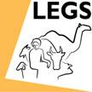

Regional Training of LEGS Trainers for Mongolia, China and South Korea

Ulaanbaatar
16 to 21 June 2013

Evaluation Summary

Training evaluation
Introduction
The participants evaluated the course using the standard LEGS ToT Evaluation Form. One participant left after attending the three-day course and she filled in an evaluation form at this stage. The other 13 forms have been analysed together.

Course objectives and relevance
Objectives
The LEGS ToT course has eight objectives:
- Describe and apply the LEGS approach.
- Identify appropriate livelihood-based livestock interventions in emergency response.
- Design and implement response interventions according to LEGS standards and guidelines.
- State the principles of adult learning and apply them to delivering a training session.
- Describe the role and responsibilities of the trainer.
- Amend a training session.
- Use a range of training skills and methods.
- Plan and carry out a LEGS Training.
For each course objective, the participants are asked to tick one of four boxes headed “Not met, Partly met, Mostly met, Fully met”. Every participant indicated that each course objective was Mostly met or Fully met. These results are summarised in the table and charts below.

Table. Results from evaluation questions on course objectives

1.1 Do you think the following objectives of the training have been met? | Not met | Partly met | Mostly met | Fully met
Describe and apply the LEGS approach | 0 | 0 | 2 | 11
Identify appropriate livelihood-based livestock interventions in emergency response | 0 | 0 | 1 | 12
Design and implement response interventions according to LEGS standards and guidelines | 0 | 0 | 5 | 8
State the principles of adult learning and apply them to delivering a training session | 0 | 0 | 2 | 11
Describe the role and responsibilities of the trainer | 0 | 0 | 1 | 12
Amend a training session | 0 | 0 | 1 | 12
Use a range of training skills and methods | 0 | 0 | 0 | 13
Plan and carry out a LEGS Training | 0 | 0 | 2 | 11

Charts. Participants’ responses on extent to which training objectives were met

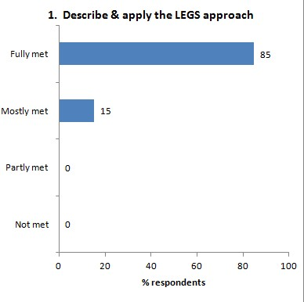 | 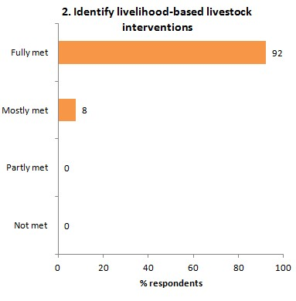
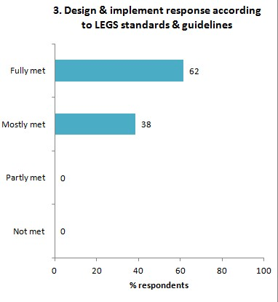 | 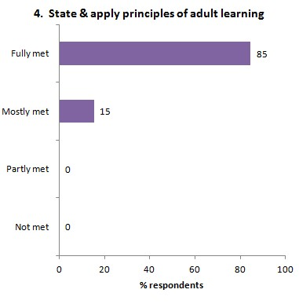
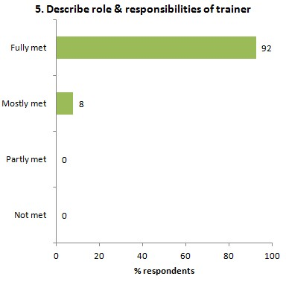 | 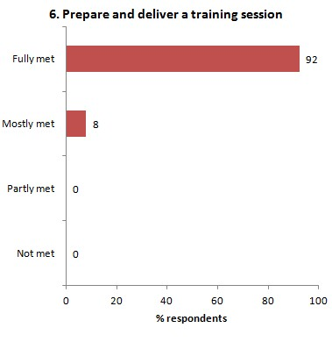
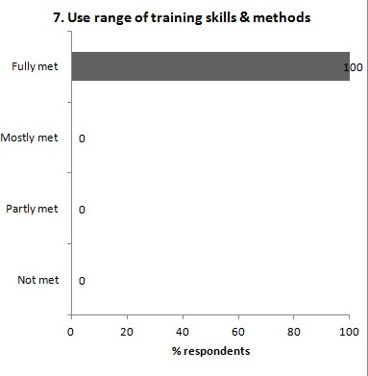 | 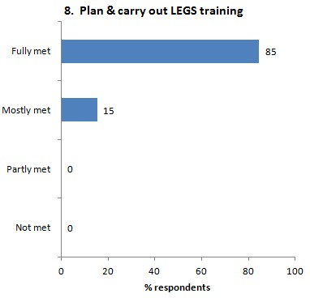
Relevance
The evaluation form asks, Was the course relevant for your work? Thirteen respondents (100%) replied ‘Yes’. They were asked ‘Why’, and the reasons given are:
- [no comment]
- Yes, directly. As our organisation [SCF] advocates and promotes the wellbeing of children, our management recognises the value of understanding livestock-based livelihoods. We could adapt and implement what is covered in the LEGS approach for our further programmes and projects.
- My organisation [Mercy Corps] is launching a new project related to livestock emergency/ disaster management.
- [no comment]
- I am a veterinarian and used to be a lecturer at the Mongolian Agricultural University. Currently I am working with one of the FAO projects. This course is very much relevant to my work. I will use this course in our project activities and in the Mongolian livestock sector.
- [no comment]
- Livestock plays a crucial role for Mongolia and one third of Mongolians are occupied by the livestock sector. In recent years, because of climate change, the interval between different kinds of disasters became close. So some people must know and be trained in international standards like LEGS which may be shared and distributed to different stakeholders of disaster-related issues. Therefore, I needed and wanted to learn techniques of LEGS.
- Yes, my work is focussing on farm animals and animal welfare. And my work’s aim is helping people to help animals. That is also LEGS’ aim.
- Red Cross work is related to disaster preparedness, recovery.
- Yes, because it looks like our work.
- Because I work for humanitarian site [Red Cross].
- I work with 387 herder groups in 50 soums of eight aimags currently. My duty is to help them to rescue their livelihood if disaster happened. Thank you.
- Course is relevant for my work as Mongolian Red Cross Society works with dzud-affected herders and livestock relief.

Workshop design
The evaluation form asks two questions, (i) What did you like about the overall design and structure of the course? and (ii) How do you think the design and structure of the TOT training course can be improved?

What you like
- The design and structure of the course is very well done.
- We had the opportunity to do exercises and receive feedback. Reading resources and materials were provided. We tried the training session.
- What I most like is to give time for trainers to prepare and present their own session. it really helping to become trainer.
- Very clear and efficient.
- All.
- Gave chance to facilitate to participants. It has improved the skill.
- Yes.
- Very good. Very logical and have designed a lot of participant group tasks.
- Very efficient and used many training methods. Objectives are clear and understandable.
- [no comment]
- Participatory course. Well developed course.
- Perfect.
- Learning initial three days, then training by participants in the last two days.

How to improve
- [no comment]
- Maybe to share some experiences of other trainees from different countries, how they managed to find funding, support, etc.
- It seemed that standards/options/checklist part needs more time and more useful methods to teach.
- [no comment]
- [no comment]
- It was very well.
- [no comment]
- No.
- Involve more participants from other organisations, especially government organisations.
- [no comment]
- No idea. Well developed course.
- Incorporate a half day sightseeing trip (it’s international training and would be interesting for foreigners).
- It was perfect.

Presentation
The form asks, The presentation and facilitation of the workshop was: Poor, Adequate, Good, Very good. The replies were:

Presentation evaluation: | Poor | 0 | Adequate | 0 | Good | 1 | Very good | 12

The form invites comments on each of the two trainers:

 | David | Emma
 | Excellent trainer and very pleasant personality. He made sure that all points were covered. The compliments and encouragement he gave to participants were very nice. | A very experienced, excellent teacher. Beyond the content of LEGS ToT, we have learned many practical tips of Adult Learning from Emma.
 | Very gentle man, provided us with lots of feedback, professional experience. Has good working experience of Mongolia and it showed, complemented this training. | Seems very strong, focussed lady. Like her very much as a woman – gives me example (inspiration) both as woman and professional.
 | Really professional and kind/ had good Mongolian ☺ | Really professional and kind.
 | Very nice, very good and useful comments/feedback were provided. | Very nice, clear, providing nice ideas.
 | He is really knowledgeable and has very good skills and experiences. Also his communication and teaching manner are excellent. | She is very good lecturer. She has very good skills and experiences. Her communication and teaching manner are excellent.
 | David Hadrill is a very professional trainer. I have learned a lot of skills from him. | Emma Jowett is a very professional trainer. This training was very fruitful with her facilitation.
 | Professional | Professional
 | Excellent | Very good
 | Excellent facilitator with good training skills. Both trainers are confident. | Excellent facilitator with good training skills. Uses variety of training methods.
 | Your present [sic] was great.
 | I learnt many things from highly professional person. | Best teacher.
 | OK | OK
 | Brilliant. Thank you! | Marvellous! Thank you!

The form asks, Do you have any suggestions for alternative ways of facilitating the TOT training? There were no comments

Content
The form asks, ‘Which session or topic did you find most useful, and why?’ Comments were:
- ToT part was new to me and I’ve learned a lot of new things.
- PRIM.
- All the sessions were so understandable. My favourite one is to prepare and deliver training.
- PRIM, it includes the identification of technical interventions and timing (two main contents).
- PRIM.
- Analysis of technical intervention and options. it is very important to appropriate planning and designing.
- All.
- PRIM. Make the analysis very clear.
- M and E plan. LEGS approaches.
- Response and coordination.
- Analysis of technical intervention, because more practical session.
- Initial assessment, PRIM are the most applicable.

The form also asks, ‘Which session or topic did you find least useful, and why?’ Comments were:
- All sessions and topics were extremely useful and interesting.
- Do not really have.
- [no comment]
- All of them are very useful.
- [no comment]
- All sessions were useful.
- [no comment]
- No.
- [no comment]
- [no comment]
- All sessions are very useful.
- [no comment]
- [no comment]

Last under Content, the form asks ‘Was there anything not included in the workshop that needs to be? If so, what is it?’ Comments were:
- Nothing particular.
- None.
- [no comment]
- Most of the things were included.
- [no comment]
- [no comment]
- [no comment]
- No.
- No.
- [no comment]
- Included everything about LEGS.
- [no comment]
- [no comment]

Satisfaction
The form asks, ‘Overall, how would you rate this course? The response was:

Satisfaction evaluation | Poor | 0 | Adequate | 0 | Good | 0 | Very good | 13

In response to ‘Any further comments’, comments were:

- No particular comment.
- Now lots of homework to do, got some “pressure” to do well ☺
- Thanks again for the great training.
- [no comment]
- [no comment]
- No.
- [no comment]
- No.
- No, please conduct more training for Mongolians.
- [no comment]
- I am very much satisfied with this course.
- A half day sightseeing tour.
- David and Emma, Ashish, please keep in touch with us for further trainings by different organisations and our next cooperation.

Finally, the form asks, ‘Tell us in one word how you would describe this training’. The replies are all positive:

- Very important
- Opportunity
- Useful
- Successful
- Wonderful. Very useful.
- Amazing
- Useful
- Excellent
- Wonderful!!!
- Great
- Wonderful
- Creative
- Efficient

