Training evaluation: LEGS TOT Southern Africa
Johannesburg, October 2010

Course objectives and relevance

Do you think the following objectives of the training have been met? | Not met | Partly met | Mostly met | Fully met
Describe and apply the LEGS approach |  |  | 4 | 13
Identify appropriate livelihood-based livestock interventions in emergency response |  |  | 3 | 14
Design and implement response interventions according to LEGS standards and guidelines |  | 2 | 8 | 7
State the principles of adult learning and apply them to delivering a training session |  |  | 6 | 11
Describe the role and responsibilities of the trainer |  |  | 5 | 11
Amend a training session |  | 2 | 9 | 5
Use a range of training skills and methods |  |  | 7 | 10
Plan and carry out a LEGS Training |  |  | 4 | 13

These responses are summarised in the following table, which also indicates how many responses were received under each objective heading.

Table. Summary of participants responses on Course objectives and relevance

Objective | Not met | Partly met | Mostly met | Fully met | No response | Total respondents
1 | 0 | 0 | 4 | 13 | 0 | 17
2 | 0 | 0 | 3 | 14 | 0 | 17
3 | 0 | 2 | 8 | 7 | 0 | 17
4 | 0 | 0 | 6 | 11 | 0 | 17
5 | 0 | 0 | 5 | 11 | 1 | 16
6 | 0 | 2 | 9 | 5 | 1 | 16
7 | 0 | 0 | 7 | 10 | 0 | 17
8 | 0 | 0 | 4 | 13 | 0 | 17

The data in the above table are displayed as charts below, showing the percentage of participants that indicated each category how much a training objective was met.

Table. Charts showing participants’ perceptions on extent to which training objectives were met.

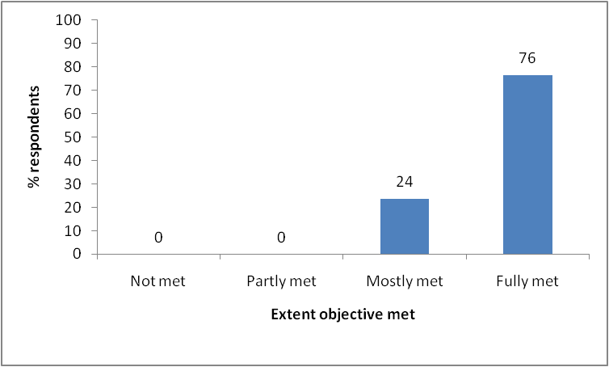 |  | 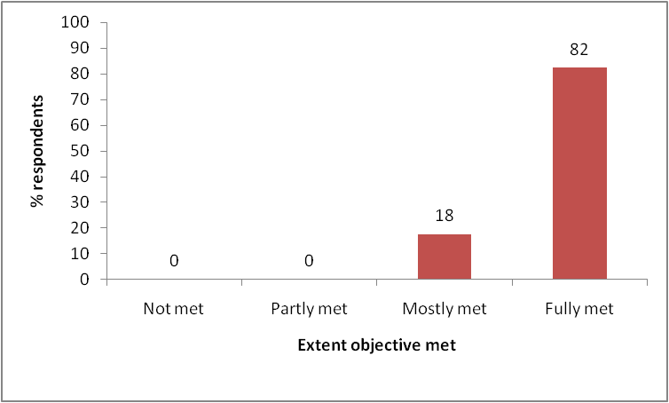
Obj. 1: Describe and apply LEGS approach. |  | Obj. 2: Identify appropriate interventions.
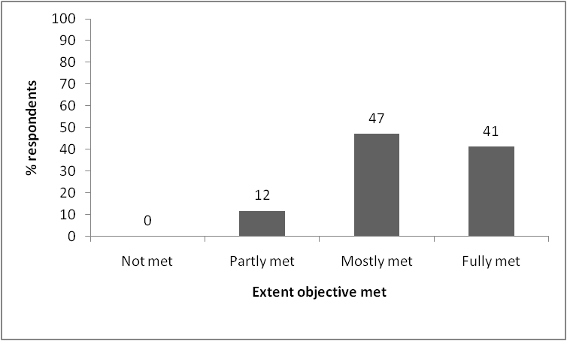 |  | 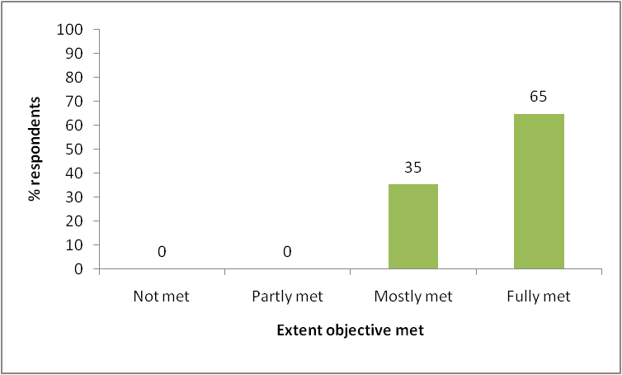
Obj. 3: Design and implement response. |  | Obj. 4: Adult learning.
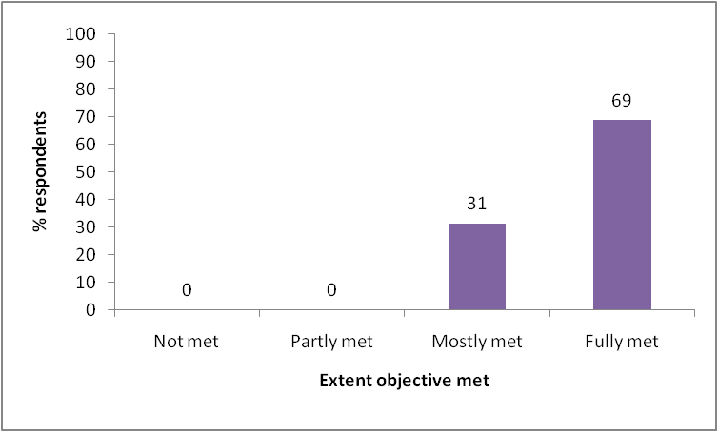 |  | 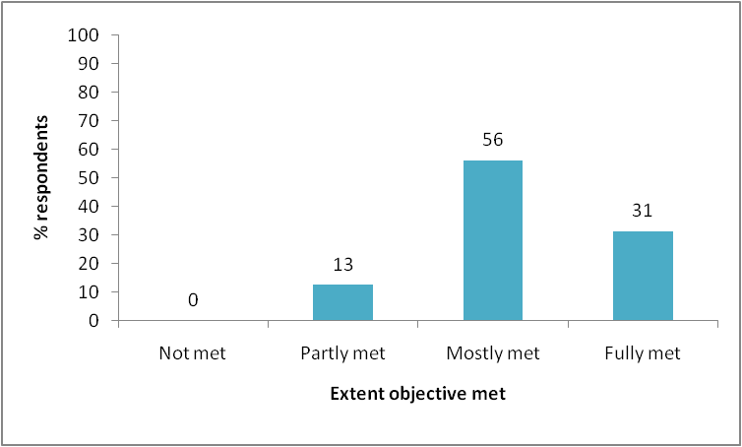
Obj. 5: Trainer role & responsibilities. |  | Obj. 6: Amend a training session.
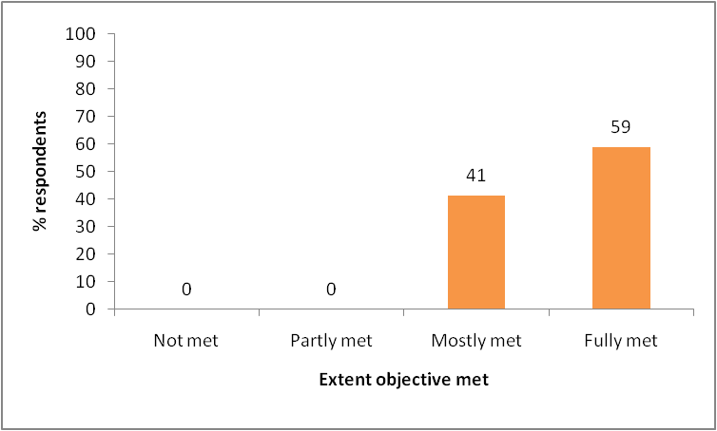 |  | 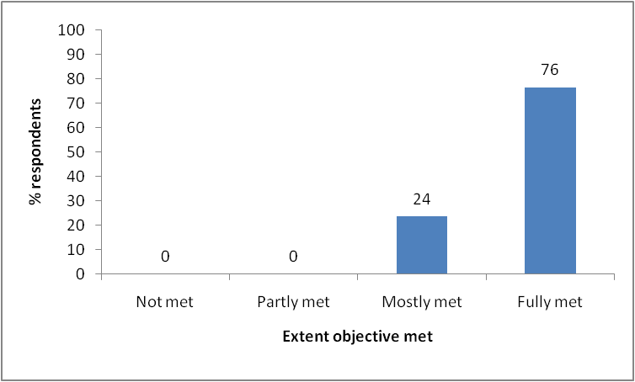
Obj. 7: Range of training skills. |  | Obj. 8: Plan and carry out LEGS training.

Was the course relevant for your work?
One hundred per cent of respondents who replied answered that the course was relevant for their work. Two did not answer the question.

Yes: 15
No: 0
No response: 2

Why?
- My work focuses on livestock interventions as part of enhancing sustainable livelihoods. It is important to institute appropriate interventions in emergencies so that livelihoods are not negatively impacted.
- No comment.
- Have been involved in disaster situations before. An expectation of my work.
- No comment.
- Livestock plays a key role in disaster recovery programme in my area.
- I work mostly with livestock farmers and other stakeholders.
- The training modules use a range of training skills and methods.
- I am working as a consultant in livestock development and animal welfare sector.
- Being from a country which faces frequent disasters, I believe that I will contribute to the attempts already underway to prevent and mitigate them. Livestock-based livelihoods have been seriously and frequently affected and LEGS will be a powerful tool to help these communities.
- My organisation is implementing projects to mitigate disasters with livestock interventions. It will help in proper planning for these interventions in future.
- Am in the emergency livestock field: it is relevant to my work.
- My responsibility in the organisation deals with a lot of livestock-based livelihoods.
- Every session was relevant because I am a capacity builder in my organisation.
- I work in livestock emergency.
- Because my work deals with livestock-related activities and most of the places where livestock is major source of livelihoods are prone to disasters such as drought and earthquakes.
- Deals with interventions (disasters) based on livestock as a means of livelihood. It’s relevant as I deal with promotion of livestock enterprises as a means of survival and commercial activity.
- No comment.

Workshop design
2.1 What did you like about the overall design and structure of the course?
- It provided a mixture of different learning methods.
- Demonstration by the trainers followed by the learners practising what the trainers taught them.
- Training agenda, that is, modelled sessions, adult learning session and training practice.
- The way it succeeded to finish within five days. I thought it would take longer.
- Practical sessions.
- Well planned and well presented.
- The facilitators’ role was good and the approach to PRIM was well thought out.
- Well thought through. Training materials well designed, really allowed participants to go through the process and learn about the LEGS approach.
- More to do with trainees. You learn by doing!
- The group presentation task and the fact that you, the facilitators, had not covered certain things the group were to present: this encouraged groups to dig deeper and understand.
- Trainers were eloquent and well versed in subject matter.
- The flow of the content. Enough time allocated to participants’ presentations.
- The training was participatory and with a diverse knowledge from participants.
- Participatory approach – logical sequence of events/sessions.
- There was good flow and linkage of one lesson (session) to the next.
- The whole structure design was very impressive.
- It was logical.

2.2 How do you think the design and structure of the TOT training course can be improved?
- There is a need to allow more time for the designing of response programmes. More case studies to look at for practice purposes.
- The course design is excellent.
- Additional time. More than five days will provide greater impact.
- By providing participants with electronic (IT) equipment such as laptop to enable them to train.
- Nothing much.
- –
- More timing to explain some of the methodologies.
- A bit more attention on the M and E component of the LEGS approach. I feel having only exposure to it through the practice block is not enough. It is an important component and some real examples of, for example, the use of the indicators would be helpful.
- Avoid if not minimise concerns of trainees, e.g. security, safety in-country, internet access, one more day for shopping …
- In future, ‘know LEGS’ should be spread to the second day because it is very important.
- First day was too cramped. Perhaps distribute handbook prior to training for participants to appreciate what is to be covered.
- More time on the ‘Deep Content’ as these are real global concerns.
- I think it’s OK.
- More time on group work, especially report back/plenary.
- By allowing more time for group work and discussions.
- Nothing.
- The structure should include critical path analysis.

Presentation

3.1 The presentation and facilitation of the workshop was: | Poor | 0 | Adequate | 0 | Good | 4 | Very good | 13

3.2 Do you have any suggestions for alternative ways of facilitating the TOT training?
- Funds permitting I would prefer it to be two-phased. Having the initial training and a refresher where trainers can reflect on real life challenges encountered.
- Not at the moment.
- Later. For now, time could be extended.
- n/a
- –
- No
- –
- –
- A little bit of details on contents.
- No
- No
- None
- No
- No
- No
- Nothing at the moment.
- More time to be allocated to topics like PRIM.

Content

4.1 Which session or topic did you find most useful, and why?
- Design of response programmes. It’s very practical and builds one’s confidence.
- I found all the topics useful.
- Adult training. Have previously overlooked a lot of key issues.
- LEGS approach.
- PRIM – very practical and participatory.
- Analysis: you will need to analyse the impact of LEGS once you implement it.
- ToT – as it is related to work as well as the M and E section.
- The session on the LEGS approach as such on day 1 and practice blocks, to get a good understanding of the approach.
- Response identification.
- PRIM. Was straightforward.
- Training skills, adult learning, etc. Learnt a lot of new things and training techniques.
- Designing PRIMs – a new learning.
- PRIM.
- Stages – the LEGS approach. The field practical sessions. Logical progress of stages/sessions.
- I found all the sessions useful as they from a complete package, i.e. from preliminary assessment to monitoring and evaluation.
- All sessions.
- PRIM – gives a guideline on which intervention to choose.

4.2 Which session or topic did you find least useful, and why?
- n/a
- n/a
- None
- n/a
- None
- –
- –
- Due to time constraint, not a lot of time was spent on further background: it would have been interesting to go into background a bit deeper.
- –
- M & E
- I think all were relevant.
- Can’t think of any.
- None
- ?
- n/a
- None
- –

4.3 Was there anything not included in the workshop that needs to be? If so, what is it?
- Can’t think of any for now.
- Nothing to suggest.
- None
- HIV/AIDS talk.
- The recognition of the link between LEGS and other livelihood interventions.
- Conservation of livestock.
- Indicators for interventions as included in Sphere to measure standards of LEGS.
- More time on M & E in LEGS workshop, maybe also as part of day 1.
- –
- –
- Spend a bit more time on the PRIM practice.
- Still think as trainers we need to be able to use the handbook for logframes. This will make the handbook more practical for the field trainees.
- Not that I can think of.
- n/a
- n/a
- None
- Appropriate livestock interventions.

Satisfaction

5.1 Overall, how would you rate this course? | Poor | 0 | Adequate | 0 | Good | 2 | Very good | 15

5.2 Any further comments
- Nil
- –
- Yourselves (Emma and David) could source funding and expose us to other ToT related to LEGS, e.g. Sphere.
- All was well, apart from the food.
- None
- –
- –
- –
- Create demand for LEGS training.
- –
- I think there may have been some issue with food provided at the venue. I was sick with running stomach on two occasions.
- Hope there will be a formal consultation process involving the ToT participants during the revision of the handbook.
- I think the facilitators were great and they were friendly to everyone.
- No
- No
- None
- Time required for this course should possibly be seven to eight days.

5.3 Tell us in one word how you would describe this training:
- Excellent
- Excellent
- Effective
- Excellent
- Useful
- Important
- Excellent
- Legsxcellent!
- Fantastic
- Fantastic and eye-opener
- Appropriate
- No regrets
- Excellent
- Excellent
- The training was well organised. The venue was also very appropriate.
- Marvellous
- Good

