Livestock Emergency Guidelines & Standards

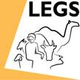

Training of LEGS Trainers – for WSPA

South and Southeast Asia Region

Manila
29 January to 03 February 2012

Evaluation Summary

Training evaluation

Introduction
The participants evaluated the course using the standard LEGS ToT Evaluation Form. Eighteen out of eighteen forms were returned. Details of the responses are given in the appendix.

Responses by participants

Course objectives and relevance
The first part covers whether the participants felt that the Course objectives were met. The LEGS ToT has eight objectives:

- Describe and apply the LEGS approach.
- Identify appropriate livelihood-based livestock interventions in emergency response.
- Design and implement response interventions according to LEGS standards and guidelines.
- State the principles of adult learning and apply them to delivering a training session.
- Describe the role and responsibilities of the trainer.
- Amend a training session.
- Use a range of training skills and methods.
- Plan and carry out a LEGS Training.

For each course objective, the participants are asked to tick one of four boxes headed “Not met, Partly met, Mostly met, Fully met”. The participants indicated that each course objective was Mostly met or Fully met. There was one single exception: one person (anonymous form) ticked that the eighth objective was Partly met.

These results are summarised in the charts below. The charts show the percentage of participants that indicated each of the four categories of how the training objective was met.

Charts showing participants’ responses on extent to which training objectives were met.

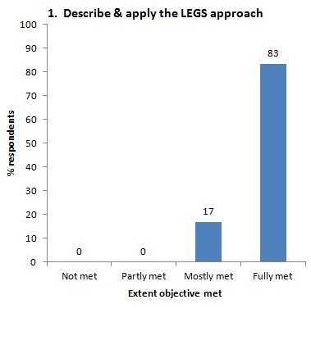 | 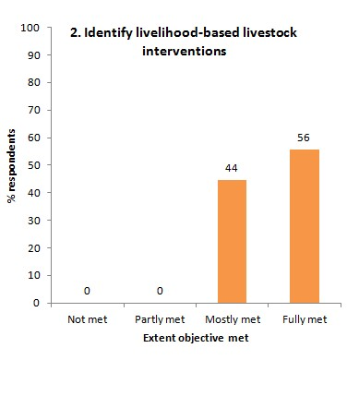
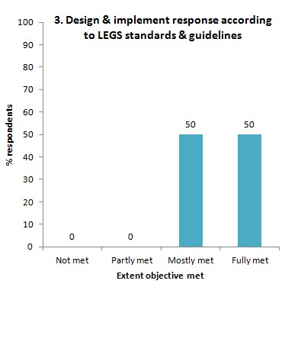 | 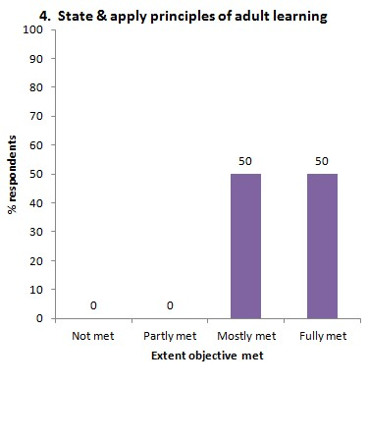
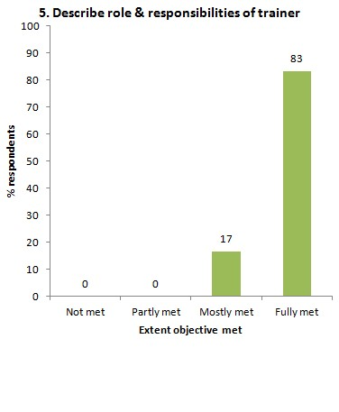 | 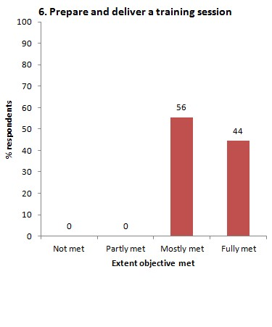
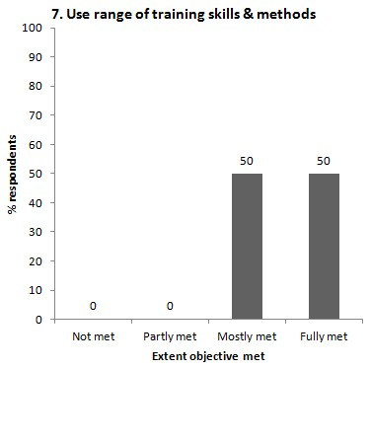 | 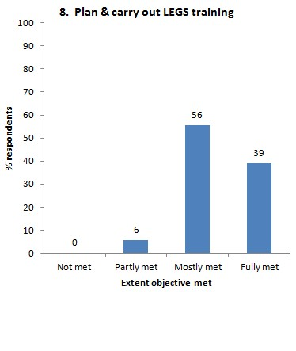

The evaluation form asks, Was the course relevant for your work? Seventeen respondents (100%) replied ‘Yes’; one did not answer the questions. They were asked ‘Why’, and the reasons given are shown in the appendix. The responses confirm that the course was very relevant to their work.

Workshop design
The evaluation form asks two questions, (i) What did you like about the overall design and structure of the course? and (ii) How do you think the design and structure of the TOT training course can be improved? Again, all responses are recorded in the appendix. The participatory nature of the course was particularly liked. As for improvement, topics that came up included:
- Case studies more country-specific, recent and linked to the local, Asian situation,
- Allow more time for the course; too much to absorb in one day.

Presentation
The form asks, The presentation and facilitation of the workshop was: Poor, Adequate, Good, Very good. The replies were:

Presentation evaluation: | Poor | 0 | Adequate | 0 | Good | 4 | Very good | 14

The form also invites comments on each of the two trainers, David and Polly. All the comments are recorded in the appendix, but a couple of highlights were:
David . . . ‘So cool!’
Polly . . . ‘Iron lady’

The form asks, Do you have any suggestions for alternative ways of facilitating the TOT training? Again, all responses are in the appendix: there are some good suggestions and the LEGS Coordinator should reflect on each one.

Content
The form asks, ‘Which session or topic did you find most useful, and why?’. The most common response was ‘all of them’ – for details, see appendix. Specific sessions named include:
- The four stages of the LEGS approach,
- Preliminary assessment, PRIM,
- Types of learners and learning cycle,
- PowerPoint presentation tips,
- Analysis of technical interventions (session 5).

The form also asks, ‘Which session or topic did you find least useful, and why?’ The most frequent answer is ‘none’, but some that were named are:
- PowerPoint tips – reason, already knew the subject,
- Case studies – reason, need to be more related to South-east Asia,
- Principles of adult learning.

Last under Content, the form asks ‘Was there anything not included in the workshop that needs to be? If so, what is it?’ Most commonly, participants gave no response or indicated ‘nothing’. Others raised the case study relevance issue again. See appendix for details.

Satisfaction
The form asks, ‘Overall, how would you rate this course?: Poor, Adequate, Good, Very good. ’ The replies were (one did not tick any box):

Satisfaction evaluation | Poor | 0 | Adequate | 0 | Good | 3 | Very good | 14

In response to ‘Any further comments’, the need for more than one hour lunch break was stated.

Finally, the form asks, ‘Tell us in one word how you would describe this training’. The replies are extremely positive, including comments such as,
- Superb,
- Couldn’t be better,
- Enlightening,
- Excellent.

Appendix I Details of training evaluation results

1 Course objectives and relevance

1.1 Do you think the following objectives of the training have been met? | Not met | Partly met | Mostly met | Fully met
Describe and apply the LEGS approach | 0 | 0 | 3 | 15
Identify appropriate livelihood-based livestock interventions in emergency response | 0 | 0 | 8 | 10
Design and implement response interventions according to LEGS standards and guidelines | 0 | 0 | 9 | 9
State the principles of adult learning and apply them to delivering a training session | 0 | 0 | 9 | 9
Describe the role and responsibilities of the trainer | 0 | 0 | 3 | 15
Amend a training session | 0 | 0 | 10 | 8
Use a range of training skills and methods | 0 | 0 | 9 | 9
Plan and carry out a LEGS Training | 0 | 1 | 10 | 7

2.1 Was the course relevant for your work?

Yes: 15
No: 0
No response: 2

Why?
- I’m heading a vet service department as city veterinarian and our program covers livestock production and protection and how it will meet the objectives of providing food and livelihood to the community (Lourdes, Philippines).
- Because I’m working for DLP that makes policy related to livestock and livelihoods (Tung, Viet Nam).
- Working with the local government means getting directly involved with the people. LEGS provides an opportunity to integrate livestock assets and livelihood (anon.).
- (no comment)
- Support my job in terms of knowledge / practice examples (case studies) / humanitarian activities of emergency responses (Hoang, Viet Nam).
- Support for my experience on training LEGS (Duy, Viet Nam).
- Because I have to work on policy and plan and from now onward I will reflect the LEGS learning into it (Vishal, India).
- I am probably going to be asked to assist WSPA DM department in organizing LEGS training (Elodie, WSPA).
- Dealing with livestock and farmers (Pranee, Thailand).
- Me being a vet working in disaster management, knowledge on LEGS is very important. It can be applied both to field work and advocacy work. WSPA takes LEGS seriously, so it is significant for its staff to be trained as trainers (Aim, WSPA).
- Even our agency during this moment focus on human live but livestock is important as community livelihood in our region and it become our responsibility to not separate between human and livestock at response emergency action (Eli, Indonesia).
- no comment, (Lerpong, Thailand)
- It helps in highlighting the importance of livestock in disasters as well as I am working for the welfare of animals (Hansen, WSPA India).
- It raises awareness about Livestock Emergency Guidelines and Standards (anon.).
- Because I work in the field of veterinary that the one important thing of my job is control and prevention of animal diseases throughout the country and also responsible for animal welfare. Therefore, the LEGS training course is very meaningful for me (anon.).
- In Red Cross humanitarian response is one of our top priorities and LEGS fits into the scene very well. As we are mentioning DRR, the livestock-based livelihood option for local needs (in Odisha) is very timely and most essential (Mang, India).
- We work in Education & Training Disaster Management (Kheriawan, Indonesia).
- Part of my work consists of training, facilitating and organising training. What I have absorbed will be utilized (Puree, WSPA).

2 Workshop design
2.1 What did you like about the overall design and structure of the course?
- Objectives thoroughly met.
- Appropriate and smooth.
- The training module was followed systematically and the lecturers did very well emphasising on time element observation.
- The way lectures, activities and energisers were combined. It was just right proportioned to help learners learn but not too hard.
- Process of the course: really appropriate. Link of different session: good.
- Plan, process, method.
- The session plan, approach. The participatory approach and time management.
- Very participative and active.
- Well prepared and participation. Learning by doing.
- Group activity for every session. It makes the course interactive because it is such a long course.
- I like the PRIM. It is easy to understand about LEGS and to make sure that we understand it well.
- No comment.
- The participatory approach made all to become one family. Several group activities and practice sessions drew out sharing of learnings.
- Plan for all session. Timebound. Content of session.
- Time schedule between sessions. Group discussion.
- The overall design including the PowerPoint presentation, structure of the course, facilitation of the workshop by the resource persons/trainers, materials and energisers. Group work, all of them.
- I like the facilitators – very patient, friendly, kind. I like the participants – friendly, kind.
- It covered what we should know. It went step-by-step.

2.2 How do you think the design and structure of the TOT training course can be improved?
- Not much on design and structure, but on dialect – translation to local dialect is vital if the trainers need to be effective.
- No comment
- I believe the design and structure will be best evaluated on its implementation at the ground level. Feedback depends on the locality where succeeding trainings will be continued.
- If the training could be a little bit more to allow for more time for prepare and deliver the training we could give more attention to use a range of training skills and methods in terms of training and practice.
- More related games / more case studies.
- OK.
- I think the participants (trainers) would be more interested to know about country-specific examples.
- I really like the structure and design that not only gives an opportunity to all participants to practice but also reinforce the learning about LEGS itself.
- Too much for one day so all information can’t be absorbed. Should have energiser during lecture.
- The first day on introduction. It was a little intense for me even though I had some knowledge on LEGS before. Maybe because I/other people did not expect it to be that knowledge-intensive.
- No comment.
- No comment.
- If possible, a field visit to a small village to apply the LEGS approach would add to the training to give a practical feel.
- No need to improve.
- No comment.
- Inclusion of more video clips. More case studies, particularly recent ones.
- I think we need good plan, support of my Head, any finance.
- Case studies added.

3 Presentation

3.1 The presentation and facilitation of the workshop was: | Poor | 0 | Adequate | 0 | Good | 4 | Very good | 13

What are your comments on (insert the name of the first trainer): David Hadrill
- Supportive!
- Exactly, friendly, professional.
- Very accommodating in replying to questions. Very observant to participants’ sensitivities.
- Excellent.
- Professional/ friendly trainer.
- OK.
- A positive man with positive attitude. An excellent trainer having excellent body language. His delivery style was excellent.
- (No comment)
- Clear and friendly.
- Very smiley trainer. Gentle and soft characteristics but got the messages across very effectively.
- All the presentations by David were very good. Calm and motivating when we feel not competent.
- Professional trainer!
- I admire the gentle but controlled attitude.
- Sometimes needs to talk louder.
- Professional and active lecture.
- Outstanding. So cool!
- David! Thanks so much. You are trainer and facilitator the best.
- Supportive to learning process.

- What are your comments on (insert the name of the second trainer): Polly Bodgener
- Terrific!
- Friendly, easy to understand, clearly expert.
- Polly is organized making sure she understands the manual.
- Excellent.
- Professional/ friendly trainer.
- OK.
- Iron lady ☺, organised thoughts, experience, she understands participants, excellent trainer, speaker and good manager to manage groups.
- (No comment)
- Lively and clear.
- A bit more assertive. Very strong character. A very good trainer.
- All the presentations by Polly also were very good. It proves she was master on LEGS training.
- Professional trainer!
- Positive energy which makes the environment lively.
- No words to say, well done.
- Professional and active lecture.
- Excellent. Ever encouraging.
- Polly! Thanks so much. You are trainer and facilitator, kind, friendly.
- Supportive to learning process.

Both trainers:
Too high☺. xx
Excellent, both of you.
David, Polly, Ash you are great!

3.2 Do you have any suggestions for alternative ways of facilitating the TOT training?
- None so far.
- More games. More case studies related to Asian regions.
- Maybe another day to provide more time (especially when participants prepare for their presentations . . .) and maybe a socialization at the start of the training to provide unfreezing and getting to know all participants.
- (i) Instructions for some activities may need refining to facilitate learners’ understanding. (ii) If more practice/examples could be given to learning cycle.
- More games, more case studies.
- No.
- It should be countrywise [sic], where participants from Government, IAG, NGOs, vets, etc will be at one place, so communication gaps should be sorted out in one go and will help in organising further training.
- No comment
- LEGS information should be split, three sessions per day and one session should be about tips and presentation techniques.
- Maybe condense it to be a full five-day course, not sure how possible it is. It think it would be a bit easier to manage logistically.
- No suggestion,everything is done well.
- No comment
- More practical ways of developing response plan (which is challenging) would help in our work (an example: showing a model response plan).
- No.
- Give more games to participants during training course.
- N/a.
- We need the handbook translated into my country language.
- No comment.

4 Content

4.1 Which session or topic did you find most useful, and why?
- All topics are relevant.
- Analysis, identification and response.
- LEGS approaches and stages: simplified but concise way of coming up with livestock responses to emergencies.
- 4 stages, because they help me understand how we can use LEGS thereby we can be confident in doing the training.
- Introduction. It provides overview about LEGS.
- Introduction. It provides overview about LEGS.
- PRIM (identification of response) because it will help in planning right intervention at right time.
- LEGS content and approach and the practice sessions.
- How to use LEGS. Can apply to use in the real situation.
- Types of learners and learning cycle. As well as other techniques. I think most o fus did not have a chance to learn about these before LEGS ToT even though most of us have had experience in training.
- All the topics are useful, especially the topic on the second day about how to prepare PowerPoint presentation because it’s general, not only for LEGS training but other training.
- –
- I liked session 3, on preliminary assessment, because it is the one which will be used in most emergency situations.
- Session 5, analysis of technical interventions and options, because it provides a tool and key method for making response programme.
- Tool LEGS analysis approach.
- All sessions.
- Each session very good for my job, in organising and facilitating.
- All of them.

4.2 Which session or topic did you find least useful, and why?
- None.
- Case study.
- PowerPoint? Maybe because I already had some teaching about it.
- N/a.
- Case studies. More related to South-east Asia.
- Case studies. More related to South-east Asia.
- All were useful.
- PowerPoint/ flip chart tips. [had done ToT before]
- No.
- No.
- There is no topic in this LEGS training least useful.
- –
- All the sessions were important and useful.
- Topic about PowerPoint because almost all participants have been working with laptop and can do it well.
- Principles of adult learning.
- N/a.
- –
- None, but more examples from each session would be much appreciated.

4.3 Was there anything not included in the workshop that needs to be? If so, what is it?
- Strategies on how our government will adopt this intervention (livelihood-based livestock interventions) in disaster management.
- I’m trying to find out.
- Socials! Hmm . . .
- More Asian examples updated.
- –
- No
- (i) Regional level examples (more specific). (ii) Maybe more time on hazard, risk, vulnerability and linkage of disasters with development. (iii) Immediate response/ planning strategy for outbreaks like swine flu, bird flu, H1N5, etc.
- Maybe more feedback on the case study activities (developing a response plan; M & E plan . . .) if anything that was presented by the groups was wrong. I understand that you don’t want to discourage participants, but maybe this contributes to people feeling not 100% confident in training other people using LEGS.
- How to deal with the affected clients.
- –
- No, everything in this workshop was included.
- –
- I feel all the points necessary were covered in detail.
- Nothing.
- –
- Overview of world’s livestock resources (contemporary) and emerging trends (though covered partially).
- –
- –

5 Satisfaction

5.1 Overall, how would you rate this course? | Poor | 0 | Adequate | 0 | Good | 2 | Very good | 15

5.2 Any further comments
- –
- –
- Thanks a lot for this great opportunity! Kudos to the trainers and the management.
- Excellent training, excellent trainers.
- –
- No.
- Individual feedback sessions were excellent.
- –
- –
- –
- –
- –
- I thank everyone involved in organizing this training and urge in planning more for India and other southern Asian countries.
- Need to provide more practice and one hour for lunch not enough for participants: it should be one-and-a-half hours.
- –
- (i) I’m looking for another chance after a year for refresher one. (ii) Challenge for self for training, at least two for Odisha, India.
- I want to say to all facilitator – you make me proud, glad, but unfortunately I don’t have fluent English.
- Some of us have main background in development work, making it difficult to explain the context. Although the course covers what we need to know to run a training workshop, challenges remaining in the limitations of knowledge in development context may prevent them from reaching highest outcomes. It would have been better to have more time in studying those contexts.

5.3 Tell us in one word how you would describe this training:
- Useful
- Useful
- Efficiently/effectively
- Can’t be better
- Experience
- Smooth process
- Aesthetic
- Very motivating and empowering
- Helpful
- (Very much) fun
- Responsibility
- Good new experience
- Excellent ☺
- Well done
- Organise
- Superb!
- We try many practice
- Enlightening☺

In fact, WSPA organised a welcome meal on the Saturday before the training began, but this participant may not have been present.

